

Stock Portfolio Management System

Software Requirement Specification (SRS) Document

Sprint Implementation

Project Timeline: 07.12.2022 to 12.12.2022

**INDEX**

1. Introduction

1.1 Purpose

1.2 What is Stock portfolio management?

1.3 Understanding stock portfolio management

1.4 Types of portfolio management

1. Design Overview

2.1 LLD (Low level)

2.2 HLD (High Level)

3 System Features

3.1 Functionality

3.1.1 void add_printfmenu

3.1.2 void add_stock_item

3.1.3 void delete_stock

3.1.4 void modify_stock

3.1.5 void trade_stock

3.1.6 void calculator_stock

3.1.7 void taxestimate_stock

3.2 System Requirements

3.2.1 Tools to be used

4. References

**INTRODUCTION**

* 1. **Purpose**

The purpose of this document is the show the requirements for the Stock Portfolio Management application, in which details of user portfolio will be kept and as updated in stocks.

* 1. **Scope**

This project aims to create the development of an Stock Portfolio Management system. Which takes the stock information such as Stock ID , name ,price ,quantity and it shows the trade of stocks and displays the stock portfolio.

**1.2 What is stock portfolio management?**

Portfolio management is the art and science of selecting and overseeing a group of investments that meet the long-term financial objectives and risk tolerance of a client, a company, or an institution.

Some individuals do their own investment portfolio management. That requires a basic understanding of the key elements of portfolio building and maintenance that make for success, including asset allocation, diversification, and rebalancing.

Investment portfolio management involves building and overseeing a selection of assets such as stocks, bonds, and cash that meet the long-term financial goals and risk tolerance of an investor.

**1.2 Understanding stock portfolio managemen**t

Professional licensed portfolio managers work on behalf of clients, while individuals may choose to build and manage their own portfolios.In either case, the portfolio manager's ultimate goal is to maximize in investment expected return within an appropriate level of risk exposure.

Portfolio management requires the ability to weigh strengths and weaknesses, opportunities and threats across the full spectrum of investments.The choices involve trade-offs, from debt versus equity to domestic versus international, and growth versus safety.

**1.4Types of portfolio management**

**Passive management** is the set-it-and-forget-it long-term strategy. It may involve investing in one or more exchange-traded (ETF) index funds. This is commonly referred to as indexing or index investing. Those who build indexed portfolios may use modern portfolio theory (MPT) to help them optimize the mix. At the opposite end of active management comes the passive investing strategy. Those who subscribe to this theory believe in the efficient market hypothesis. The claim is that the fundamentals of a company will always be reflected in the price of the stock. Therefore, the passive manager prefers to dabble in index funds which have a low turnover, but good long-term worth.

[**Active management**](https://www.investopedia.com/terms/a/activemanagement.asp) involves attempting to beat the performance of an index by actively buying and selling individual stocks and other assets. [Closed-end funds](https://www.investopedia.com/terms/c/closed-endinvestment.asp) are generally actively managed. Active managers may use any of a wide range of quantitative or qualitative models to aid in their evaluations of potential investments.

The aim of the active portfolio manager is to make better returns than what the market dictates. Those who follow this method of investing are usually contrarian in their approach. Active managers buy stocks when they are undervalued and start selling when they climb above the norm.  
  
Active [portfolio management](http://www.moneyworks4me.com/stocks/how-to-invest/stock-portfolio-management-tools-manage-equity-investment) involves the quantitative analysis of companies to determine the cost of stock in relation to its potential. To do this, the active manager shuns the efficient market hypothesis and instead relies on ratios to support his claim.  
  
To downsize risk, the active manager prefers to diversify investments amongst the various sectors. The issue with active portfolio management is that it all comes down to the manager's skill. But should you find one with the necessary know how, the value investing method will likely bring in good gains.

**Discretionary Portfolio Management**A discretionary manager is given full leeway to make decisions for the investor. While the individual goals and time-frame are taken into account, the manager adopts whichever strategy he thinks best.  
Once the cash has been handed to the professional, the investor sits back and trusts that the profits will roll in.

**Non-Discretionary Portfolio Management**The non-discretionary manager is simply a financial counsellor. He advises the investor in which routes are best to take. While the pros and cons are clearly outlined, it is up to the investor to choose his own path. Only once the manager has been given the go ahead, does he make a move on the investor's behalf.  
  
Whether you decide to use a portfolio manager or you choose to take on the role yourself, it is important to opt for a viable strategy and ensure that it is put forward in a logical way. The merit of maintaining a sensible portfolio is that it cuts down the confusion while providing investments that fit the individual's goals.

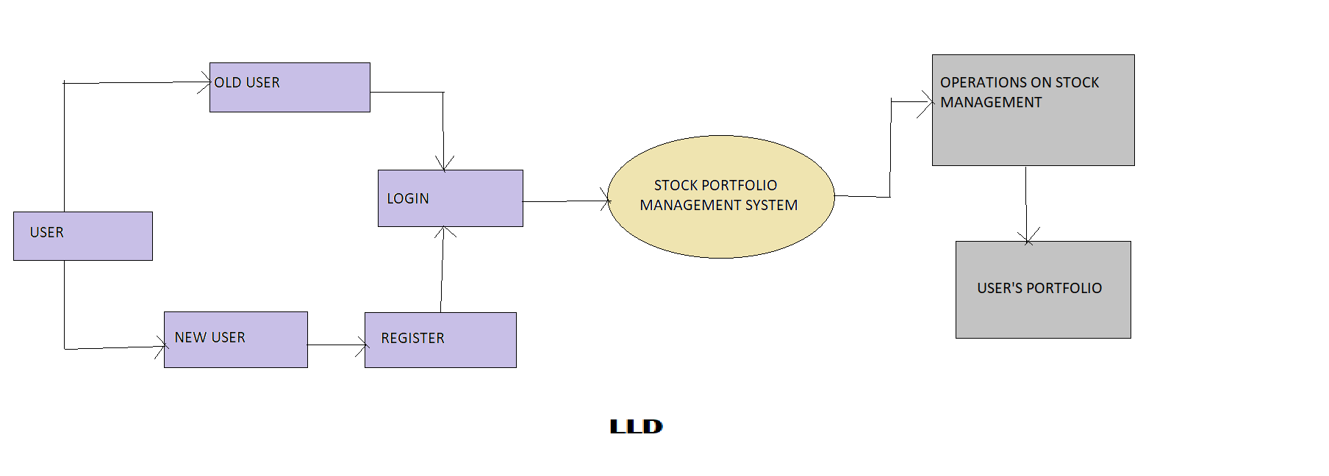

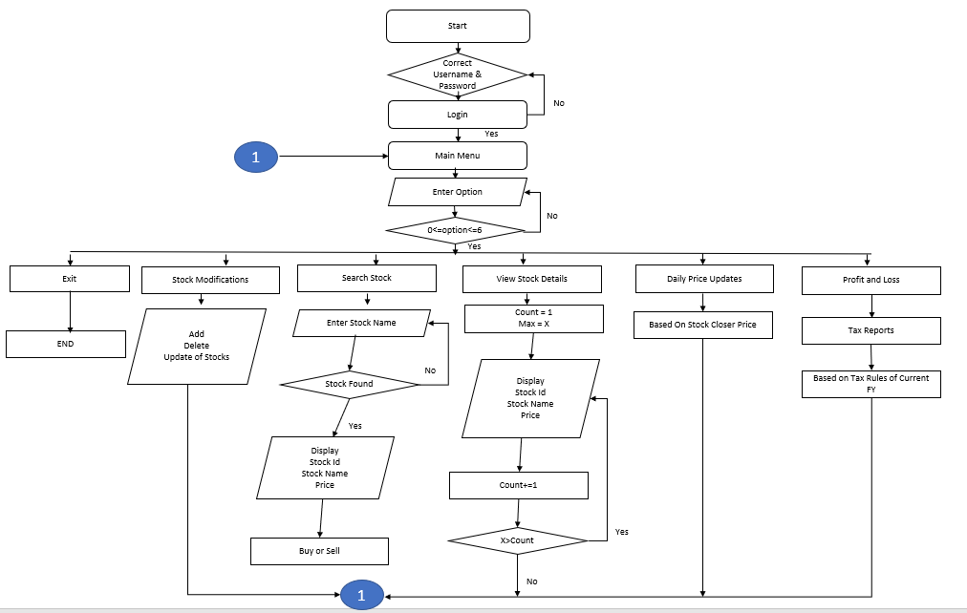

**HLD**

* 1. **SYSTEM FEATURES**

**Functionality**

* + 1. void add_printfmenu

This function will print menu screen for user like what are the options they have and can perform operations accordingly.

* + 1. void add_stock_item

This function is used to add stocks in the existing stock.

* + 1. void delete_stock

This Function is used to delete any stock from the stock data.

* + 1. void modify_stock

One can modify their stocks depending upon their requirements or choice.

3.1.5 void trade_stock

By using this function we can buy the stocks we want and can sell the stock according to our choice.

3.1.6 void calculator_stock

One can calculate profit and loss of a particular stock.

3.1.7 void taxestimate_stock

Can calculate tax depending upon the range.

* 1. **SYSTEM REQUIREMENTS**

|  |  |
| --- | --- |
| Name of the Module | Top level menu and user interaction.  Single OS authenticated user. |
| Handled by | Devi Priya Putta, Deepthi |
| Description |  |

|  |  |
| --- | --- |
| Name of the Module | Stock master menu for addition, deletion and modification of stock. Stock will not be deleted if a position in a specific stock is existing or there is trade in stock during current FY. |
| Handled by | Varsha Goli, Shruthi, Swetha |
| Description | Developed code on update and delete operations and implemented . |

|  |  |
| --- | --- |
| Name of the Module | Stock trade/contract note addition , deletion and modification. Trade inputs will consists of stock code, Quantity, B or S, Trade Price and Other expenses. |
| Handled by | Deepthi , Shruthi , Devi Priya |
| Description | Researched and developed all the conditions and functions on Buy and sell. |

|  |  |
| --- | --- |
| Name of the Module | Application will maintain daily price movements by a stock closure price provided in a file at a specific location. P&L and MTM calculator and report displayed on selecting a menu |
| Handled by | Swetha, Varsha, Shruthi |
| Description | Developed code in creating sales record and designed dataflow diagrams and flow charts |

|  |  |
| --- | --- |
| Name of the Module | Tax estimate report based on Tax Rules of Current FY. They will be hard coded. Reports |
| Handled by | Deepthi , Devipriya |
| Description | Developed code on update the overall tax reports. |

**3.2.1 Tools to be used**

Language**:** C

Compiler: gcc

Operating System: Linux Environment

**5.REFERENCES**

The references are:

<https://corporatefinanceinstitute.com/resources/wealth-management/stock-screener/>

<https://www.investopedia.com/terms/m/movingaverage.asp>

<https://www.nirmalbang.com/knowledge-center/use-moving-average-for-buying-stocks.html>

<https://www.nseindia.com/market-data/live-equity-market>

<https://www.researchgate.net/publication/251335107_Market_Timing_With_Moving_Averages>